Layout Characterization of Course Schedule and Behavior Planning
The XD Mathematical Modeling Team focuses on time management and academic planning for college students. Figure 1 displays a simplified timeline with circles (see Figure 2 for a detailed one), where blue dots indicate scheduled classes and white dots denote free periods. Note that each dot represents 2 lesson hours. Including the weekends, we can similarly extend the timetable to a 5×7 matrix, organized horizontally into five major blocks and vertically from Monday to Sunday.

Figure 1 Schematic layout of single-week course schedule(weekends excluded )
The curriculum schedule is closely tied to the professional training program. The distribution structure of courses varies across different majors, semesters, and even within the same semester. Moreover, courses differ in categories and credit requirements. In this context, quantifying the workload of university students to enhance time management efficiency and academic planning quality becomes particularly crucial. Please develop a mathematical model to address the following issues:
- Provide a structural feature characterization of course distribution, and establish an evaluation model for the rationality of course layout from both short-term (single semester) and long-term (four years of university) perspectives.
- In the extended 5*7 matrix, white dots need to consider the reasonable allocation of four types of activities: personal life (leisure, entertainment, and other personal affairs), courses (classes in the timetable) study (previewing, homework, reviewing, etc.), and practical activities (kinds of contests, etc.), as well as social services (class committee, clubs, etc.), in order to achieve all-round development of college students. Your task is to set reasonable goal and efficiency indicators (corresponding to each lesson hour) for personal life, course study, practical activities, and social services, then provide an action-filling algorithm for the white dots (note that weekends are included), further give a comprehensive evaluation of your plan, and specific simulation results are recommended to be given.
Note:
The attachment 1 is the implementation measures of modular assessment of comprehensive quality.
The attachment 2 is the profiles of candidates for the 2025 Principal's Scholarships.
The above attachment is for reference only.

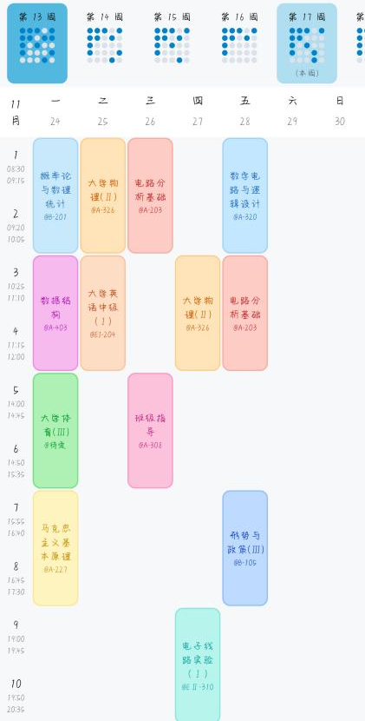
Figure 2 a detailed single-week course schedule

